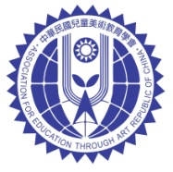
中華民國兒童美術教育學會
Association For Education Through Art of the Republic of China
The 57th World School Children’s Art Exhibition
Dear Sir/Madame,
We are pleased to invite you to participate in the 57th World School Children’s Art Exhibition to be held from August 5 to August 23, 2026, in Taipei, Republic of China (Taiwan). We warmly welcome works from young artists worldwide. Your participation will enrich this art exhibition and enable us to promote cross-cultural understanding among younger generation.

ORGANIZER：
Association For Education Through Art of the Republic of China

CO-ORGANIZER：
National Taiwan Art Education Center

AWARDS：
Based on the committee of judges’ evaluations, certificates and/or medals will be awarded to the winners of outstanding works.
●Special Gold Medal ●Gold Medal ●Silver Medal ●Bronze Medal ●Excellence Award

ENTRY RULES：
- Eligibility for participants：Schoolchildren aged 3-15
- Artworks：Artworks must be two-dimensional; three-dimensional works are not accepted.
Oil paintings, watercolor, wood cut prints, pencil sketches, crayon drawings, pastels, collages, Printmaking, graphic designs…etc.
- Size：Recommended approx. 55cm x 40cm (Due to exhibition picture frame.)
- One entry per person.
- One entry label must be filled out and attached to the lower right-hand corner of the back of each artwork submitted.
- A list of entries also needs to be filled out and include with each package of entries submitted. You must enter with valid address, phone number, and e-mail address to receive award.
- If possible, please send digital file of the “List of Entries” form to our email address. (s3985529@gmail.com)
- Committee of Judges：Artists, educators, psychologists, and art educators.
- The rules can be downloaded from Arts Education Network (http://ed.arte.gov.tw) and association’s website. (https://www.kaearoc.org.tw/html/)
- Artwork submitted will become the property of the organizer and will not be returned.
- For organization with difficulty of sending artwork, please contact us. (s3985529@gmail.com)

DEADLINE FOR ENTRIES：April 15, 2026 (Postmarked)
Judging：May 2026
Result Announced：June 2026
Exhibition：August 2026

SUBMISSION ADDRESS
The Association for Education through Art
No. 43, Nanhai Rd., Taipei City, 100052 Taiwan
TEL：+886-2-23110574
TAX ID:00981931

EXHIBITION ADMISSION OFFICE
The Association for Education through Art Kaohsiung Office
33F.-3, No. 80, Minzu 1st Rd., Sanmin Dist., Kaohsiung City, 807413, Taiwan
TEL：+886-7-3130700
FAX：+886-7-3130711
E-mail：s3985529@gmail.com

HANDLING OF PERSONAL INFORMATION
Acquisition of personal information
Association For Education Through Art of the Republic of China (the “association”) will acquire applicants’ personal information as indicated below when accepting applications with artwork.
・Name
・Age
・Gender
・Country of residence
・Name of affiliated school/institution/organization
Use of personal information
The association shall use applicants’ personal information obtained when receiving their applications for the World School Children’s Art Exhibition only for the purpose of running the event when sending out award notifications and prizes. The association shall not use personal information it has received from persons concerned for any other purpose. The association shall only use the Special Gold Medal winner’s personal photo for publishing the exhibition book, at the awards reception, and art exhibitions to be held in Taiwan conforming to its data protection regulation. The association shall not share the Photos with third parties or use them for commercial purposes. All different uses of the Photos must be specifically authorized by the applicants through their legal representative.
Nondisclosure of personal information to third parties
The association shall not provide personal information of applicants to a third party except for subcontractors without the consent of the persons concerned.
Cases in which personal information shall be disclosed
The association reserves the right to disclose personal information without consent from the applicants if the provision of personal information is required by law, or when the provision of personal information is necessary for the immediate protection of the life, body, property, or other significant interests of an individual.
Announcement and rights of applicants
The association shall announce the winners of Special Gold Medal, Gold Medal, Silver Medal, and Bronze Medal (collectively referred to as “the winners”) in the book “The 57th World School Children Children’s Art Exhibition of Republic of China” published by the association along with its website and Facebook page. Excellence Award winners will be announced on association’s website and Facebook page.
For inquiries:
International applicants with inquiries about the association’s guidelines for handling private information are kindly advised to contact Exhibition Admission Office.
ENTRY LABEL
Please attach one of these forms to the lower right-hand corner of the back of each entry
----------------------------------------------------------------------------------------------------------------------------------

The 57 th World Schoolchildren's Art Exhibition
Entry Label
Entry No.  (Match list of entries) |  |  | Nationality
Title
Name
Gender |  | Age
School/Institution/Organization
Note: Please Print in English if possible

----------------------------------------------------------------------------------------------------------------------------------

The 57 th World Schoolchildren's Art Exhibition
Entry Label
No.  (Match list of entries) |  |  | Nationality
Title
Name
Gender |  | Age
School/Institution/Organization
Note: Please Print in English if possible

CONTACT PERSON：
COUNTRY：
SCHOOL/INSTITUTION/ORGANIZATION：
ADDRESS：

POSTAL CODE (COUNTRY)：
TEL： | E-Mail：
For country required TAX ID/KYC alike import rule to receive award package：
The 57th World School Children’s Art Exhibition
Republic of China (Taiwan)
List of Entries
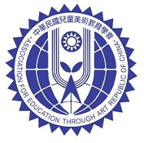

編號  Entry No. | 姓名  Name | 性別  Gender | 年齡  Age | 畫題  Title | 獎項  Award
FOR EXHIBITION STAFF USE ONLY

Media Reports
〝56th World School Children’s Art Exhibition Awards Ceremony 〞
The 56th World School Children’s Art Exhibition of the Republic of China in 2025 featured participants from 41 countries, including the United States, Japan, Malaysia, Thailand, and Saint Lucia. Over 50,000 domestic and 10,000 international entries were submitted.
The awards ceremony for domestic Special Excellence winners and international representatives took place at 2:00 PM on August 17 at the Nanhai Theater, National Taiwan Art Education Center. Nineteen students from Thailand, the Philippines, Malaysia, Hong Kong, and other countries attended in person, highlighting the exhibition’s significance as a platform for international arts and cultural exchange. The event garnered coverage from major media outlets.
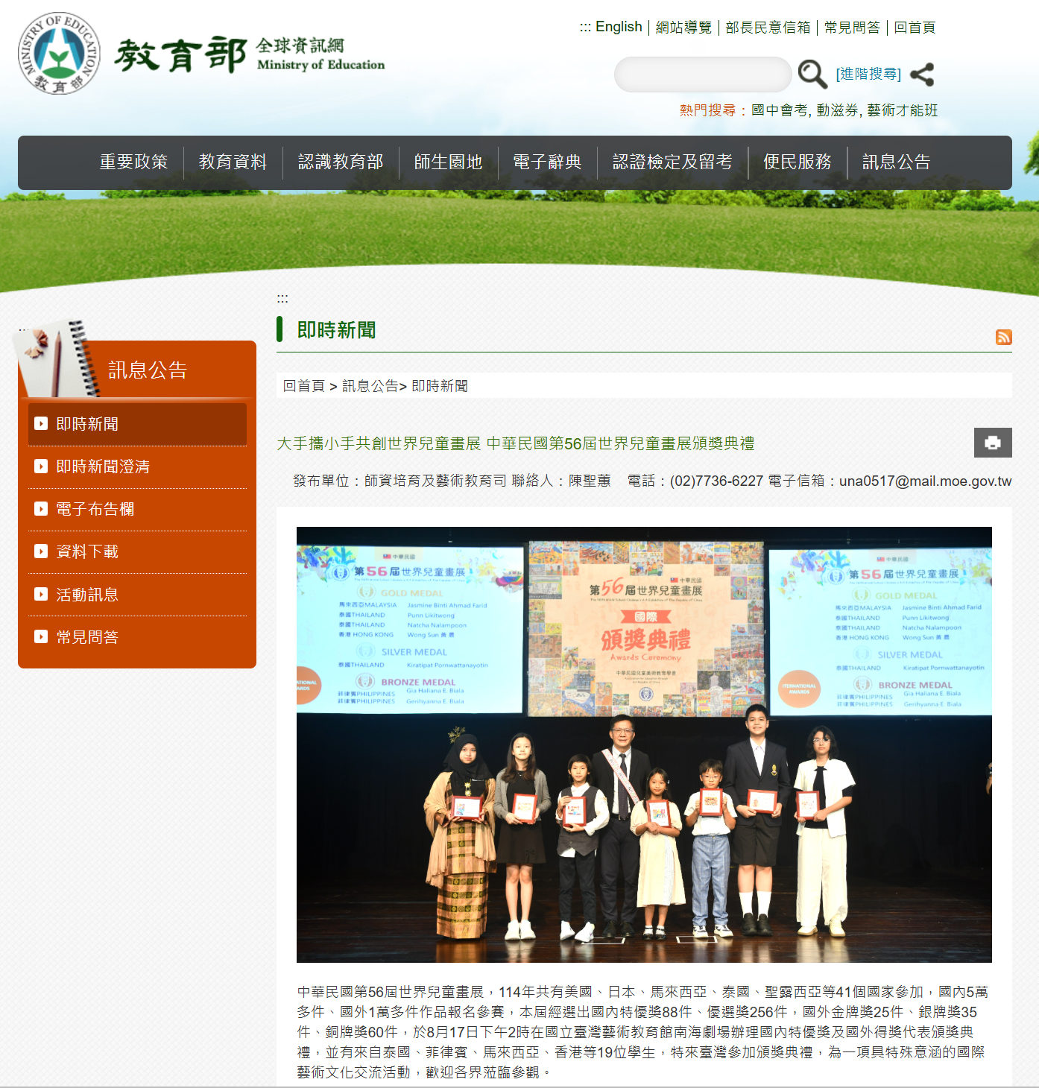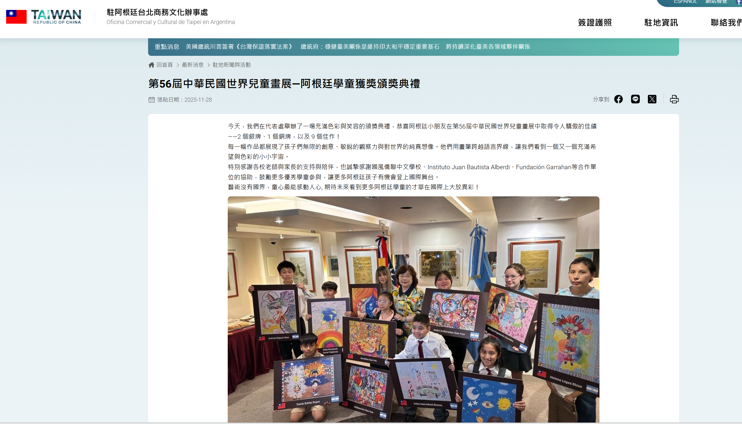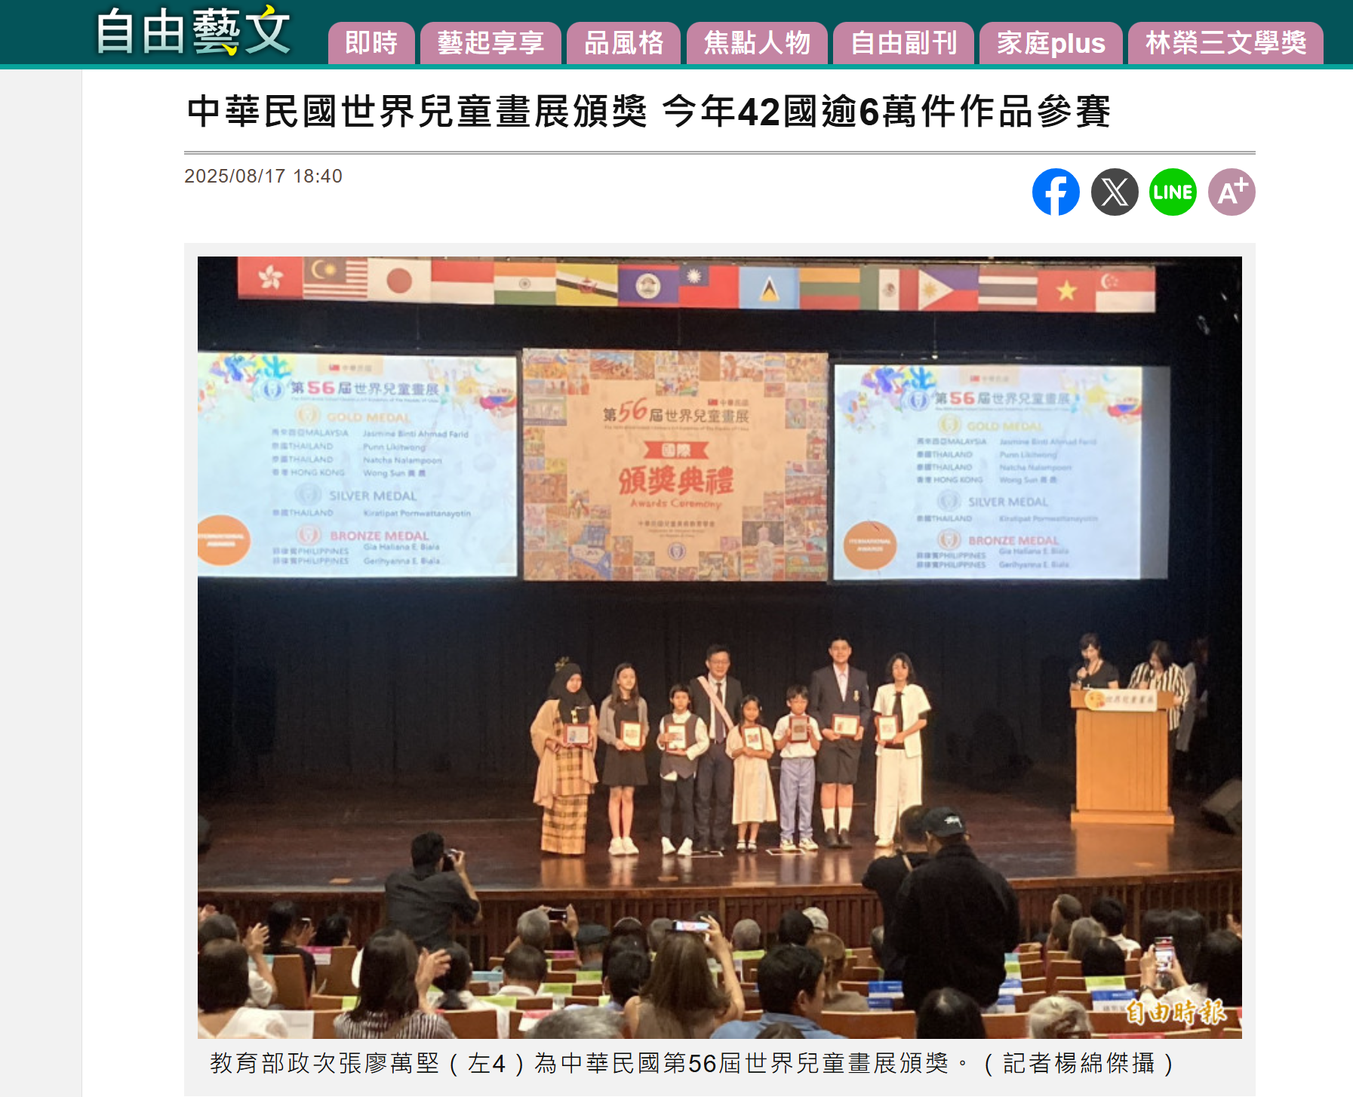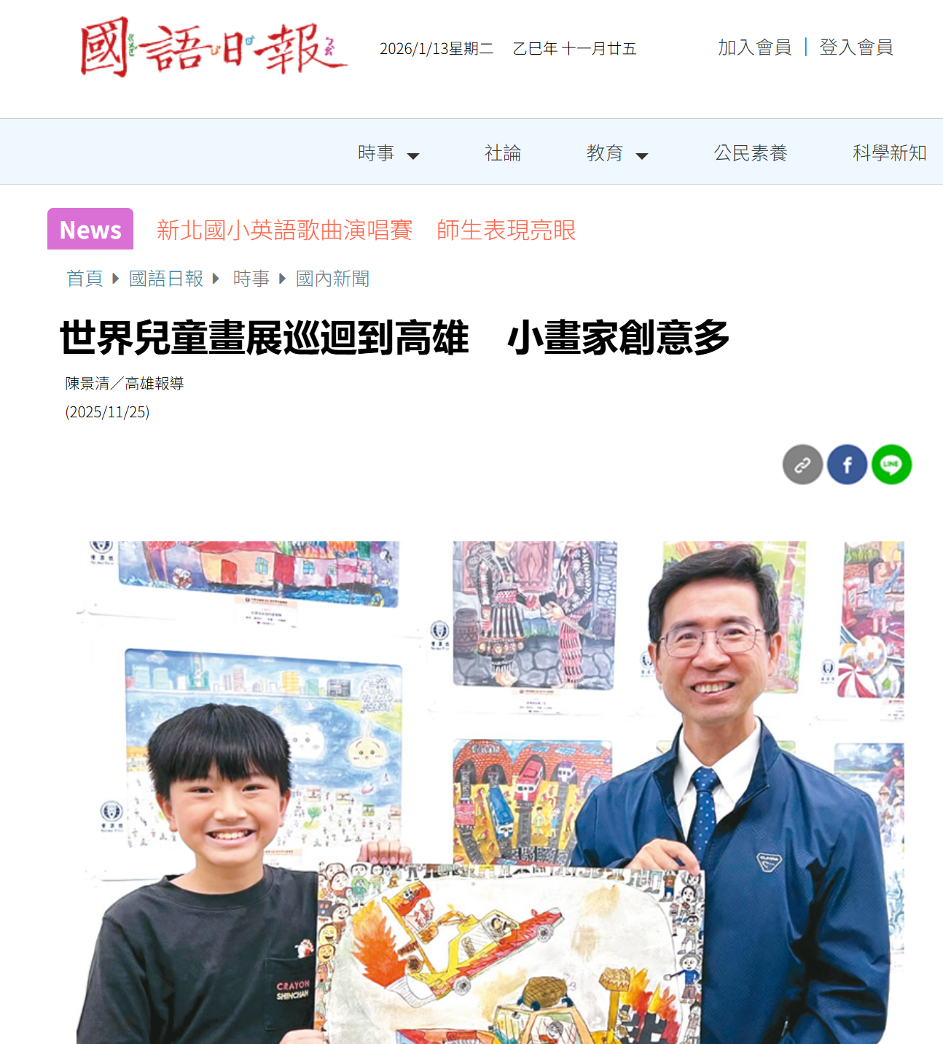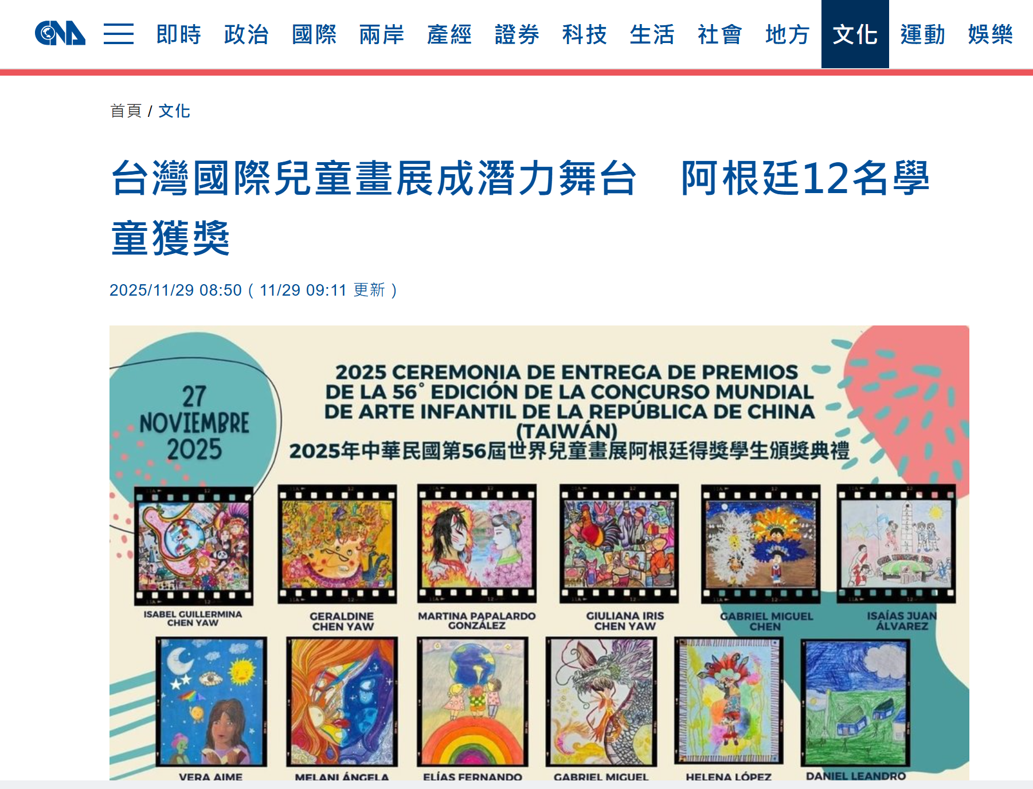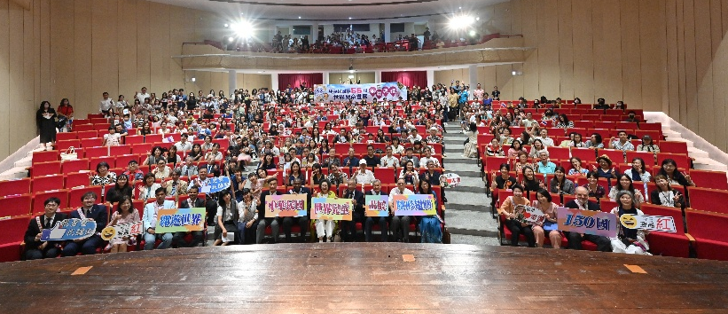
- 教育部 大手攜小手共創世界兒童畫展 中華民國第56屆世界兒童畫展頒獎典禮 https://www.edu.tw/News_Content.aspx?n=9E7AC85F1954DDA8&s=D09826FC9EEB2655
- 第56屆中華民國世界兒童畫展—阿根廷學童獲獎頒獎典禮 https://www.roc-taiwan.org/ar/post/25729.html
- 中華民國世界兒童畫展頒獎 今年42國逾6萬件作品參賽https://art.ltn.com.tw/article/breakingnews/5146938
- 國語日報https://www.mdnkids.com/content.asp?Link_String_=23BP00000JOLAHR
- 中央社https://www.cna.com.tw/news/acul/202511290019.aspx
- Ink free news https://www.inkfreenews.com/2026/01/06/whitko-students-shine-at-world-art-exhibition/
- Belize Joins Taiwan in Celebrating 114th National Day https://www.greaterbelize.com/belize-joins-taiwan-in-celebrating-114th-national-day/
- 澳洲駐台辦事處 Australian Office in Taipei https://www.facebook.com/share/p/17iuXs3Pgf/

